Emotion Detection Theoretical Paper

Gavrus Dragos Andrei

14.04.2025

1. Introduction

Emotion recognition by NLP has become an important domain of research and application due to the increase in textual data requirements within the domains of customer feedback analysis, monitoring of social media, and dialogue with chatbots. Recognizing emotions through NLP involves advanced algorithms that analyze text data for detecting anger, happiness, sadness, frustration, and other states that are highly valued in enabling businesses to improve customer experiences by effectively handling these subtle emotions of clients in support interactions.

Emotion detection, as an application of NLP, has achieved remarkable progress with the integration of deep learning and transformer-based models that can extract even subtle emotional cues from text data.

Other techniques, such as the detection of sentiment polarity and emoji-based analysis, further enhance the accuracy of emotion recognition, thus making it suitable for diverse contexts like social media analytics and feedback systems.

One of the major challenges that lie within this domain involves handling the complexity of language at the levels of contextual variation and ambiguity. Recent works have tried to address these challenges using emotion ontologies and multimodal approaches, where text is combined with other data types for richer insights. Emotion detection in textual big data also requires scalable solutions that can process vast datasets in real time, a challenge tackled by employing advanced machine learning frameworks.

1. Emotion recognition

The three major directions in emotions recognition are: categorical/discrete, dimensional, and appraisals-based approaches :

• Basic emotion model: the categorical approach - claims there are a small number of basic emotions that are hard-wired in our brain and recognized across the world. Each affective state is classified into a single category.

• Dimensional feeling model: the dimensional approach - that feelings (which he distinguishes from emotions) can be described as pleasantness–unpleasantness, excitement–inhibition and tension–relaxation. An example is Plutchik’s wheel of emotions. In Plutchik’s wheel of emotions, primary, secondary, and tertiary dyads are presented. Each dyad describes the distance between two emotions as follows: the primary dyad combines emotions next to each other the secondary dyad combines two emotions when another emotion between them is skipped the tertiary combines two emotions when two other emotions between them are skipped.

• Componential appraisal models: proposes that emotions are extracted from our appraisals (i.e., our evaluations, interpretations, and explanations) of events. These appraisals lead to different specific reactions of different people. It defines emotions as a balanced reaction to events, agents, and objects, and considers balanced reactions to differentiate between emotions and non-emotions. This approach is very suitable for affect sensing from the text.

There are three main approaches to emotion detection in NLP:

* Rule-based, which uses predefined keywords or patterns to infer emotions.
* Classical machine learning, where models like SVMs or Naive Bayes learn from features like word frequency.
* Deep learning, which uses models like LSTMs or transformers to capture complex patterns in text automatically.

3.Papers

Paper 1: Emotion Recognition in Natural Language Processing: Understanding How AI Interprets the Emotional Tone of Text  
*Manoj Kumar, Concepts IT Inc, 2024*

This paper is a comprehensive review of recent advancements in emotion detection using NLP. It highlights how deep learning, especially transformer-based models like BERT, has significantly improved the detection of emotions such as happiness, anger, sadness, and frustration in text. The review emphasizes the integration of emotion ontologies, emoji-text sentiment polarity, and multimodal approaches to capture emotional nuance more accurately.

The paper discusses multiple datasets, including Twitter, Yelp, Reddit, and Facebook posts, and compares techniques ranging from LSTM and CNN to traditional methods like Naïve Bayes and SVM. The transformer models showed the best performance, achieving up to 92.3% accuracy on textual emotion classification tasks.

The key findings stress the growing business relevance of emotion detection in areas like customer feedback analysis, healthcare chatbot interactions, and mental health monitoring. It also identifies challenges such as language ambiguity, cultural differences in expression, and lack of labeled data for non-English languages. The paper concludes by encouraging further work in contextual modeling, real-time processing, and ethical AI deployment.

Paper 2: Text Emotion Detection Using Machine Learning and NLP  
*Amal Shameem et al., Akshaya College of Engineering and Technology, 2022*

This study explores the use of traditional machine learning techniques combined with NLP for detecting emotions in English text. The authors frame emotion detection as a content-based classification task, focusing on six primary emotions: joy, sadness, anger, surprise, fear, and hate. The paper emphasizes that extracting emotions from written text is more complex than from speech or facial expressions, due to the varied ways people express themselves in writing.

The research compares several machine learning models, including Support Vector Classifier (SVC), LinearSVC, RandomForestClassifier, and DecisionTreeClassifier. The best performance was achieved by RandomForest in terms of accuracy, while DecisionTreeClassifier had the highest F1 score and efficiency, with an F1 score of 94.1%. The model was trained on a dataset of annotated blog posts and underwent standard NLP pre-processing like tokenization and feature extraction using DictVectorizer and one-hot encoding.

A key contribution of this paper is its practical, engineering-focused approach: building and optimizing models using real-world textual data, and comparing their effectiveness in emotion classification tasks. The study also incorporated semantic resources like WordNet and ConceptNet to improve emotional context understanding.

The paper concludes that while classical ML methods can perform well, capturing deep semantic meaning and contextual nuances still presents a major challenge—especially in unstructured social media data where slang, abbreviations, and mixed emotions are common.

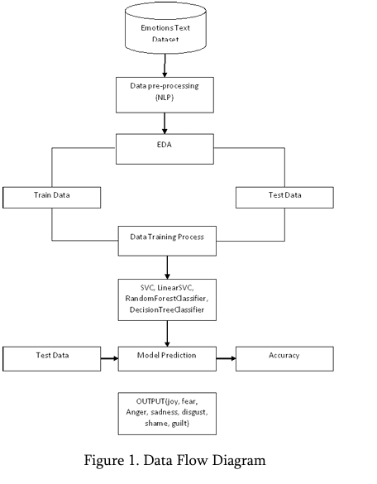

Paper 3: A Review on Emotion Detection by Using Deep Learning Techniques  
*Tulika Chutia and Nomi Baruah, Artificial Intelligence Review, 2024*

Although this paper primarily explores deep learning methods, it provides a broad and detailed background on the role of NLP in text-based emotion detection. It frames emotion detection as a specialized task within Natural Language Processing, where the goal is to identify emotional states—like joy, sadness, or anger—from written text.

The paper outlines how traditional NLP methods such as tokenization, part-of-speech tagging, TF-IDF, and Bag-of-Words (BoW) are used for feature extraction before feeding data into classifiers. It distinguishes emotion recognition from sentiment analysis, highlighting that emotion detection requires finer granularity—for example, distinguishing between emotions like fear and sadness rather than just labeling text as “positive” or “negative.”

In the review, classic NLP classifiers such as Support Vector Machines (SVM), Naive Bayes, and Decision Trees are discussed for their historical role in early emotion detection systems. The paper also notes the importance of emotion lexicons, such as WordNet-Affect and domain-specific ontologies, for mapping words to emotion categories.

A critical insight from the paper is that language ambiguity, cultural differences, and context dependency pose significant challenges for NLP-based emotion detection. For example, a word like “great” might signal happiness in one context but sarcasm in another—an issue not easily solved by simple rule-based or keyword-driven models.

Another emphasized challenge is the lack of multilingual datasets. Most annotated datasets are in English, which means models trained on them often fail to perform well in low-resource languages. The authors argue that more culturally and linguistically diverse corpora are needed to create NLP models that work globally.

The paper concludes that while deep learning models now dominate the field, NLP still forms the foundation—handling everything from data cleaning to syntactic and semantic analysis. The combination of NLP techniques with modern neural networks has significantly improved emotion recognition systems, but fundamental challenges rooted in language itself remain unresolved.

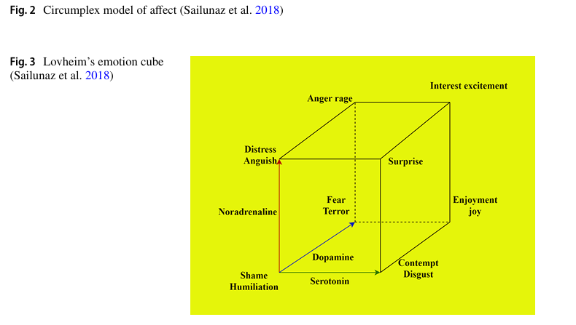

4. Emotion detection challenges

* Emotion detection in NLP comes with several important challenges. One of the biggest is the ambiguity of language. For example, a phrase like “I can’t believe this happened” could express happiness, sadness, or even anger depending on the situation, and models often struggle to correctly interpret such nuances.
* Another major issue is cultural and linguistic differences. The way people express emotions can vary a lot from one language to another. For example, in English, someone might say “I’m feeling down” to express sadness. In Romanian, a person might say “Am inima grea,” which literally translates to “My heart feels heavy.” While both phrases express sadness, they do it in different ways—one is idiomatic, the other metaphorical. If a model is trained only on English expressions, it may completely miss or misclassify the Romanian version.
* There’s also a lack of large, well-labeled datasets for emotion detection, especially in less-resourced languages like Romanian. Most existing datasets are in English, which limits the ability to train accurate models for other languages.
* Finally, emotions are context-dependent. A sarcastic comment like “Great job!” might seem positive to a model, when in reality it could be negative depending on the tone or situation. These subtleties are still hard for most NLP systems to fully grasp.

**5. Conclusion**  
Emotion detection in text is becoming increasingly important as digital communication grows. From customer reviews to social media posts, understanding emotions helps machines interpret human behavior more accurately. This has valuable applications in areas like mental health, education, customer service, and marketing. While recent advancements in NLP and deep learning have improved accuracy, challenges like language ambiguity, cultural differences, and lack of multilingual data still remain. Continued research in this field is essential to build AI systems that are not only intelligent, but also emotionally aware and responsive.

References

1. Emotion Recognition in Natural Language Processing: Understanding How AI Interprets the Emotional Tone of Text - *Manoj Kumar, Concepts IT Inc, 2024*
2. Text Emotion Detection Using Machine Learning and NLP  
   *Amal Shameem et al., Akshaya College of Engineering and Technology, 2022*
3. A Review on Emotion Detection by Using Deep Learning Techniques  
   *Tulika Chutia and Nomi Baruah, Artificial Intelligence Review, 2024*